A Busy Teacher’s Guide to making good resources quickly

Jon Drury (Sevenoaks School) & Alex Young (Wellington College)
see p6-9 for the resource we’re going to make
jdd@soaks.org ABKY@wellingtoncollege.org.uk

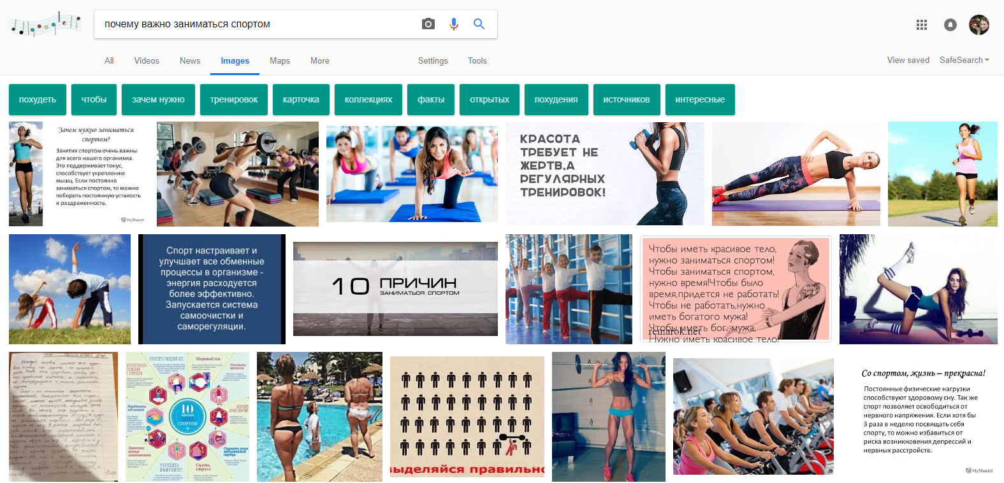

TIP #1: Use Google/Yandex to find images and infographics

Let’s suppose you’re doing the topic of sport/health. Go to www.google.ru and put «почему важно заниматься спортом» in the search box. Then click ‘images’, which will get Google searching for pictures.

- photos are great for discussion, but best for end of topic, when pupils already have ideas/vocab
- infographics are great for starting a topic: short sentences, great for key vocab and ideas

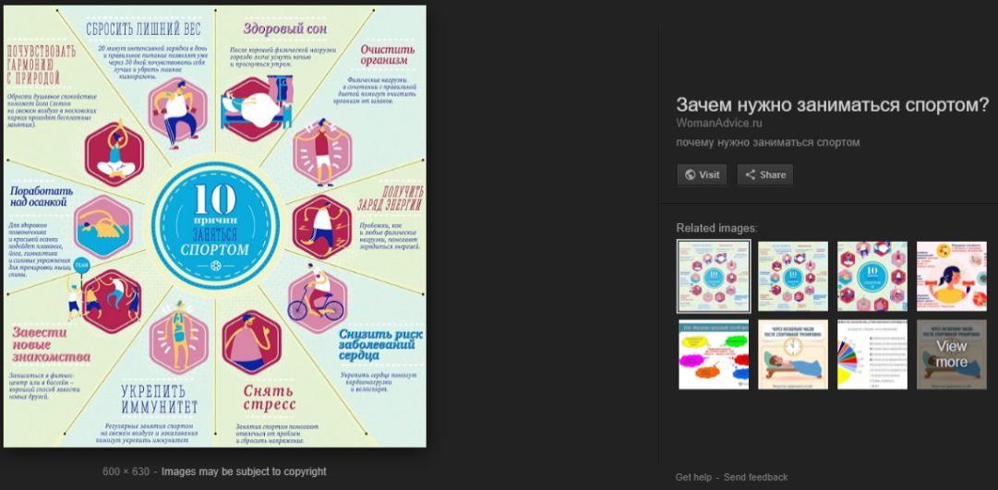
The three circled above look particularly promising. To get a good version of the picture, click on it, and a box (below) appears. You can then Right-click on the image and select ‘Copy image’. You can then paste it (CTRL-V) into a Word document or a Powerpoint, depending on what kind of resource you want to make.

However, often it is useful to see the webpage the image is from, so Left-click on the ‘Visit’ button to go there.

You can also click on ‘related images’, which may also be useful, or the same image in higher resolution.
TIP #2: Use and adapt texts that already exist
Useful Shortcuts:
CTRL-C = copy
CTRL-X = cut
CTRL-V = paste
CTRL-Z = undo
CTRL-A = select all
CTRL + mouse wheel = zoom
CTRL + left mouse = multiple selections

If you want to find/adapt a whole text for your pupils, it’s worth looking at several sites to find one which is best. Ideally:

- not too long, with relatively accessible language
- broken into clear sections, sub-headings, or lists
Other helpful search terms might be: топ 10, 10 причин, 10 совет(ов), список, интервью, инфографика

For our example, visiting the website of the infographic above actually takes us to a nice article, at http://womanadvice.ru/zachem-nuzhno-zanimatsya-sportom. You can use the shortcuts above (or the Right mouse button) to cut and paste the text and pictures into a Word document or a Powerpoint.

TIP #3: Do some basic formatting

TEXT: Select the text you want to format (holding down CTRL allows you to select separate sections)
Right click. Select Font. Choose something you easy to read, e.g. Calibri, Regular, 13 size
Right click. Select Paragraph. Here you can change the line spacing, e.g. Multiple at 1.2

PICTURES: Make sure text flows around any pictures or text boxes. Right-click on the picture, hover over ‘Wrap text’ and select ‘Square’. This also means you can easily move the picture anywhere on the page.

TIP #4: Use ‘snipping tool’ to add authentic elements
USING SNIPPING TOOL

- find the snipping tool by typing it into your windows search box (bottom left)
- I recommend you right click on it and select ‘pin to taskbar’, so it’s always easily accessible!
- Open the ‘snipping tool’
- select ‘New’
- choose the rectangle of the screen you want to copy.
- CTRL+C copies it to the clipboard
- CTRL+V pastes it into your doc
TIP: for the best resolution, make the thing you want to copy as large on screen as possible

When you copy and paste from a website, the original formatting and layout is usually completely lost.

Snipping tool is brilliant for copying images straight from the screen, so they will look in your document exactly like the original.

Note that these are now images, so you can’t select text within them. But very useful for this example to use the ‘snipping tool’ to copy the top banner of the ‘Womanadvice.ru’ webpage, with all its index headings, and its search box.

I also copied the Facebook ‘like’ button, for another authentic touch.

As with pictures (above), I recommend selecting ‘square’ text wrapping for the images, once they are in your document.

TIP #5: Add stress using www.russiangram.com
Adding stress manually in Word (by creating a helpful shortcut key):

- Select ‘Insert’ menu (top)
- Select ‘Symbol’ (right)
- Select ‘More symbols’
- Character code: 0301
- Select ‘Shortcut key’
- Choose CTRL-́` (top left key)
- Assign. Close.
You can now easily insert stress by placing the cursor to the right of the vowel with your right hand, and pressing CTRL-` with your left!

Select the Russian text you want to stress. Copy it.

Go to www.russiangram.com and paste the text into the box. Click on ‘annotate’, and magically your text will be stressed! You can now cut and paste the stressed text back into your document.

Hint 1: this will almost certainly mess up the text formatting you did in Tip #3, so if you know you’re going to stress your text, do it first, before you start making your text look too pretty.

Hint 2: www.russiangram.com is pretty good, but sometimes it will give you two options if unsure, e.g всё|все. You need to go through your document removing the alternates. To help you do this you can use CTRL-F to find the ‘|’ sign, which will lead you to each pair of variants.

TIP #6: Reference the hyperlink/webpage at the bottom as your source.

Not only is it good for the pupils to see you referencing work which is not your own, it will also allow you to rediscover the website in future, should you need to!

TIP #7: Make it look nice

Insert blank lines to add space, increase the font size for headings, add some bold/italics? Adjust the margins of the page (using the ruler bars at the top and to the left) if you need more space.

TIP #8: Add some vocabulary (via an Excel spreadsheet)

Excel is the best place for you to keep vocab lists (for a thousand reasons I can’t go into here! )
Making nice tables in Excel:

- Select your area
- Right-click, then ‘Format cells’
- Select ‘Border’ tab, then you can add nice borders, and fainter/ dotted lines in the centre
- Select ‘Alignment’ tab for shrinking text to fit (very useful), and for wrapping text.
- Fill cells with colour, merge cells, align text, bold/italic, USING:

Select the words you want to have in your list. You can do this really quickly by holding down CTRL, to select multiple words/phrases at the same time. Use CTRL-B if you want to make them bold, then CTRL-C to copy them. If you now CTRL-V to paste them in Excel, you’ll find they are in a nice column, in separate cells. Adjust the Russian if required. Add your English translations to the right.

Make it into a nice table (see right). Give it a Quizlet reference (we’ll make the Quizlet set next). Copy and paste it into your Doc. Adjust the size, using the ‘bobbles’ at the corners.

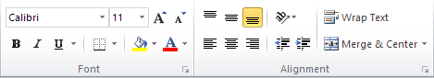
HINT: there are different ways to use a vocabulary box. It may be better to include only the MOST USEFUL words and phrases, rather than simply the hardest words. What would you most like your pupils to be able to say?

TIP #9: Add some simple exercises, or interesting pictures for consolidation, extension and differentiation

The infographic we originally found, for example, is really great with some valuable ideas and vocab.

By adding a simple 2x5 table, you can give pupils the structure to extract useful vocabulary and ideas from the infographic themselves, hopefully developing their independent learning skills along the way.
Adding tables in Word is relatively easy: use the ‘insert’ tab and then the ‘table’ icon. Alternatively, make a nice pretty table in Excel and copy it across

Adding a few humorous or interesting pictures can also be an entertaining way to explore a topic, especially once you have covered some basic vocabulary and ideas. The picture to the left is a good example. Add some related questions!

TIP #10: Add the vocab list to Quizlet (or Memrise), using the IMPORT function

Quizlet is great. It’s free, it’s very easy to use, and kids can access it via a free mobile app.

Go to www.quizlet.com, and log on. Click on ‘Create’ in the top menu bar. Name your new set.

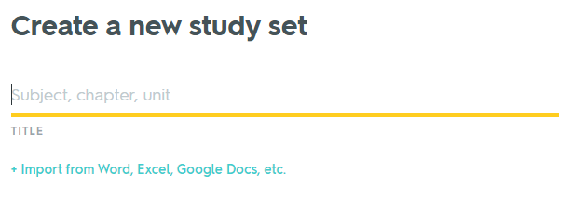
HINT: you may find it helpful to adopt a system for naming your Quizlet files, to help your pupils find them. This might include including a personal codeword in the title (e.g. JDD-Rus) or by giving each set a specific and unique code at the end (e.g. JDD#287).

Here’s the really clever bit. If your vocab lists are in Excel, you can use the Import function to simply copy
and paste the words into Quizlet – no need to laboriously type them in.

Having clicked the ‘Import’ option above, copy and paste your wordlist from Excel, then click ‘Import’.

Click ‘Create’. It will now ask you to confirm the languages (Russian and English). Do this, then hit ‘Create’.

You have created the set. It’s that simple.

APPENDIX #1: Here is a useful ‘official’ infographics site, and a list of just some of the categories they have infographics for

http://infographics.wciom.ru/cat.html

Тематический каталог

Политика
Внутренняя политика
Армия и оборона
Бюрократизм. Административная реформа
Государственная Дума, выборы в ГД
Государственное, политическое устройство
Гражданские права и свободы
Институты государства и общества
Коррупция
Общественные деятели
Патриотизм. Государственные символы. Гимн
Политики и государственные деятели
Политическая активность населения
Политическая идеология, ценности и нормы
Политические партии
Политический экстремизм. Фашизм
Правительство. Министерства
Президент. Выборы президента
Протестные настроения
Силовые структуры. Национальная безопасность
Терроризм
Электоральные предпочтения и поведение

Постсоветское пространство
СНГ. Организации на территории бывшего СССР
Общие проблемы постсоветского пространства
Белоруссия. Союзное государство
Украина. Молдавия

Дальнее зарубежье
Ближний Восток
Дружественные и недружественные страны
Европа и Евросоюз
Китай, Япония, другие страны Восточной Азии
НАТО
ООН. ВТО. Россия в международных организациях
Роль России в мире
США. Другие американские страны

Регионы России
Социально-экономическое положение в регионах

Общество
Социальные проблемы
Алкоголизм
Жилищно-коммунальное хозяйство. Тарифы
Здравоохранение
Иммиграция и эмиграция. Приезжие. Ксенофобия
Курение
Межнациональные отношения. Национализм
Наука. Техника. Технологии
Национальные проекты
Образование, навыки
Преступность
Проблемный фон
Самооценка материального положения
Социальная защита. Льготы. Монетизация льгот
Социальная структура общества. Богатые и бедные
Социальные настроения, социальное самочувствие
Угрозы и страхи населения
Экология. Климат

Религия, образ жизни, культура
Возрастные проблемы
Воспитание детей
Гендерные проблемы
Досуг
Историческая память. Ожидания от будущего
Литература и искусство
Мораль. Взаимоотношения между людьми
Одежда, имидж
Отношение к здоровью, лечение и самолечение
Питание, диета
Пользование компьютером, телефоном
Пользование транспортом
Праздники, обычаи
Религиозность. Конфессии. Религиозная терпимость
Религия и государство, армия, школа
Спорт, физкультура
Туризм, путешествия

Семья

Средства массовой информации
Интернет
Общие проблемы СМИ. Доверие к СМИ. Цензура
Политическая информация. Новости
СМИ и политика
Телевидение

Экономика
Инфляция. Цены
Рынок труда. Занятость. Безработица
Экономическое положение страны

